MACULAR DEGENERATION
To reduce your risk of progression:
- Avoid/cease smoking
- Take your recommended vitamin daily as directed by your doctor
- Get regular exercise
- Control pre-existing health conditions such as high blood pressure, high cholesterol, cardiovascular disease and obesity
- Protect your eyes from the sun by wearing sunglasses and/or a hat
- Check the Amsler grid regularly and report any changes on the grid or in your vision immediately
- Ingest dietary sources of Lutein and Zeaxanthin that help protect the macula: dark leafy green vegetables, peas, squash, brussel sprouts, corn and broccoli
Vitamin Recommendations:
______ AREDS 2 formula vitamin:
- “PRN Macular Vitamin” (which can be ordered through our office and shipped directly to you)
- “PreserVision” (available over-the-counter)
______ Lutein/Zeaxanthin supplement:
- “PRN NuMaqula” (which can be ordered through our office and shipped directly to you)
- Other formulations available over-the-counter (look for a formula with at least 10mg of Lutein and 2mg of Zeaxanthin)

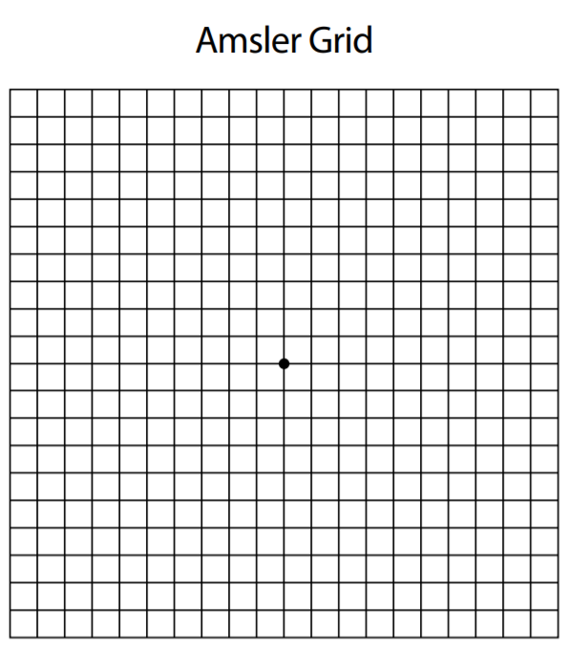

Directions for using the Amsler Grid:
- Test with your glasses used for reading.
- Hold the grid approximately 14-16 inches from your eyes.
- Test each eye separately. Cover your other eye with your hand.
- Keep your eye focused on the dot in the center of the grid and answer these questions:
  - Do any of the lines in the grid appear wavy, blurred or distorted?
  - Do all of the boxes in the grid look square and of the same size?
  - Are there any holes, missing boxes or dark areas in the grid?
  - Can you see all corners and sides of the grid while keeping your eye on the dot in the center?
- Repeat while covering your other eye.

IMPORTANT – Report any changes you see on the grid to your eye doctor immediately.

